**Project Proposal for SBE3124 Capstone Project**

1. **Centralized Collaboration Dashboard**

* A single interface where both IT and Engineering can log in.
* Core functions: shared calendar, equipment booking visibility, and project task uploads.

1. **Automated Task & Schedule Management**

* Calendar feature with equipment booking to prevent overlaps.
* Task upload function with urgency-level tagging (“Urgent” tasks automatically highlighted in a “Must Do” section).
* Automated reminders/notifications for deadlines and urgent tasks.

1. **Streamlined Personnel Coordination**

* Simple “Check-in/Check-out” or one-click location status update for on-site engineers (no full GPS tracking to reduce privacy pushback).
* Real-time visibility of who is available or occupied, minimizing repeated calls.

1. **“Quick links” Section in the Dashboard**

* To address this, the dashboard can include a dedicated “Quick Links” panel. The recurring client meeting link will be pinned there, visible and accessible to everyone at all times. With one click, team members can join the meeting without searching through old messages or emails. This ensures smoother meeting starts, saves time, and improves professionalism when engaging with clients.

1. **Shared Glossary Feature in the Dashboard (If time permits, I will create something like Chatgpt instead of rule-based function)**

To reduce unnecessary interruptions and improve knowledge sharing, the dashboard will include a shared glossary of IT and Engineering terms.  
Key functions:

* **Searchable Acronym Finder**: Quickly look up terms like “SAT” or “API” without needing to ask.
* **User Contributions**: Allow both teams to add new terms and explanations to keep the glossary updated.

**Low fi Prototype:**

September

|  |  |  |  |  |  |
| --- | --- | --- | --- | --- | --- |
| 1 | 2 | 3 | 4 | 5 | 6 |
| 7 | 8 | 9 | 10 | 11 | 12 |
| 13 | 14 | 15 | 16 | 17 | 18 |
| 19 | 20 | 21 | 22 | 23 | 24 |
| 25 | 26 | 27 | 28 | 29 | 30 |

= urgent/deadline

= meeting

= shipping to be arrived

Users can click in to view detailed descriptions, such as which shipment is arriving, which assignment is urgent, or what meeting is scheduled

**Hi Fi Prototype:**

**Streamlined Personnel Coordination**

**Low fi Prototype:**

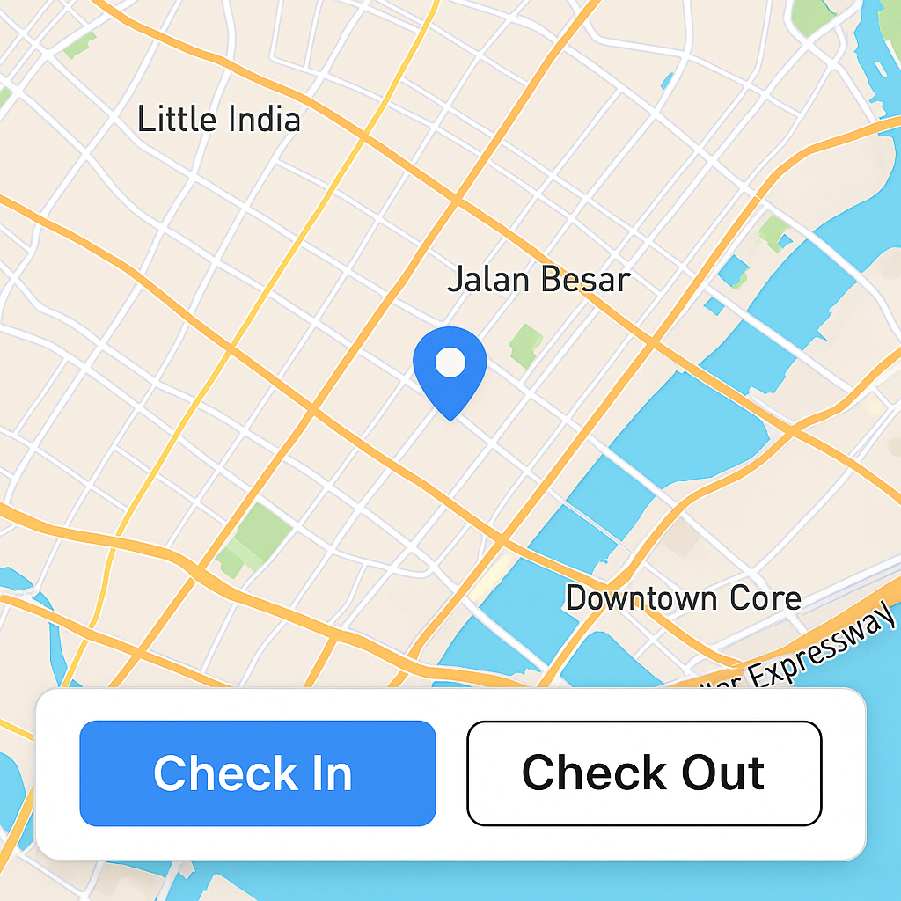**

**Hi fi Prototype:**

**“Quick links” Section in the Dashboard**

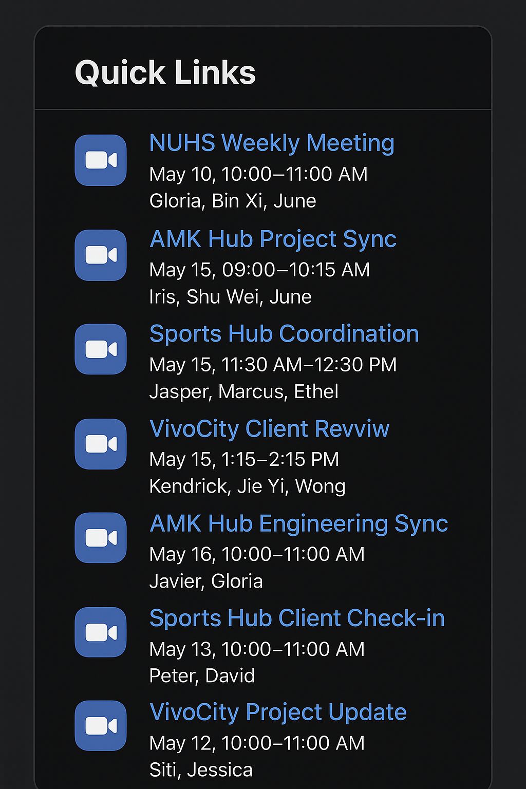

**Shared Glossary Feature to be added in the Dashboard (Help function instead)**

**HVAC abbreviations** (Main sub header)

**Air Temperatures** (sub header)

* **RAT –** Return Air Temperature
* **SAT –** Supply Air Temperature
* **MAT –** Mixed Air Temperature
* **OAT –** Outdoor Air Temperature

**Pressures** (sub header)

* **SAP –** Supply Air Pressure
* **RAP –** Return Air Pressure
* **DP –** Differential Pressure

**Air Handling Components** (sub header)

* **AHU –** Air Handling Unit
* **FCU –** Fan Coil Unit
* **VAV –** Variable Air Volume (box/damper)
* **PAD –** Pre-Cool Air Damper
* **OAD –** Outdoor Air Damper
* **RAD –** Return Air Damper

**Water Side** (sub header)

* **CHW –** Chilled Water
* **CHWP –** Chilled Water Pump
* **CWP –** Condenser Water Pump
* **CT –** Cooling Tower
* **CH –** Chiller

**Temperatures (Water)** (sub header)

* **CHWS –** Chilled Water Supply Temperature
* **CHWR –** Chilled Water Return Temperature
* **CDWS –** Condenser Water Supply Temperature
* **CDWR –** Condenser Water Return Temperature

**Other HVAC/Controls** (sub header)

* **RH –** Relative Humidity
* **CO₂ –** Carbon Dioxide level
* **EC Fan –** Electronically Commutated Fan
* **SP –** Setpoint (e.g., SAT-SP = Supply Air Temp Setpoint)

**BMS Quick Action Matrix** (Main sub header)

**Temperature Control** (sub header)

* **Zone Temperature (ZT)** → Adjust FCU/ VAV damper air volume or CHW valve position
* **Supply Air Temperature (SAT)** → Adjust AHU chilled water valve (cooling coil) or duct heater
* **Return Air Temperature (RAT)** → Indirectly controlled by supply air temperature and volume

**Humidity Control** (sub header)

* **Relative Humidity (RH) too high** → Activate/Increase reheat coil (electric/duct heater) to remove moisture (cool → reheat cycle)
* **RH too low** → Activate humidifier (steam/atomizing type)

**Ventilation & Air Quality** (sub header)

* **CO₂ level too high** → Increase Outside Air Damper (OAD) opening / PAD (Pre-cool Air Damper)
* **Low O₂ / stuffy air** → Same as CO₂ → Adjust OAD
* **VOC/IAQ sensors abnormal** → Trigger purge cycle (open dampers, increase fan speed)

**Airflow & Pressure** (sub header)

* **Supply Air Pressure (SAP)** → Adjust AHU/EC Fan speed (VSD)
* **Return Air Pressure (RAP)** → Adjust Return Fan speed
* **Differential Pressure (ΔP Room–Corridor)** → Adjust exhaust fan / supply air balance

**Water Side** (sub header)

* **Chilled Water Supply Temp (CHWS)** → Adjust Chiller setpoint or chiller staging
* **CHW Flow** → Adjust CHW Pump VSD
* **Condenser Water Temp (CDWS)** → Adjust Cooling Tower fan speed or tower bypass valve

**Other Setpoints** (sub header)

* **Occupancy-driven ventilation** → Adjust VAV box damper position and minimum OA rate

**Energy saving mode** → Adjust SAT reset, fan speed reduction, CHW reset

**Hi fi Prototype:**

**Comparison Between Microsoft Teams and Proposed Centralized Collaboration Dashboard**

|  |
| --- |
| **Visualized Scheduling and Resource Conflict Prevention**  Teams’ calendars are limited to personal or meeting events. My dashboard visualizes equipment usage, personnel availability, and task deadlines on a single view helping to prevent overlap and resource conflicts.  **Explanation**: The dashboard’s calendar is not just for meetings; it is an operational control panel. It displays project schedules, equipment bookings, and site personnel updates together, something that Teams’ separate calendar and chat functions can’t achieve. |
| **Shared Glossary and Knowledge Hub**  Teams does not have a built-in way to manage technical jargon or acronyms across disciplines. Your shared glossary feature directly addresses one of the key problems terminology gaps between IT and Engineering.  **Explanation**: A key innovation is the shared glossary feature. Unlike Teams, where information is buried in chats or files, this dashboard provides an integrated, searchable reference for technical terms reducing repeated clarifications and improving cross-department understanding. |
| **Purpose-Built vs. Generic Communication Tool**  MS Teams is designed for general communication such as chat, video meetings, and file sharing. My dashboard, on the other hand, is a workflow-optimized system specifically tailored to IT–Engineering operations.  **Explanation**: While Microsoft Teams facilitates communication, it doesn’t directly manage workflows or operational data between departments. My dashboard is purpose-built for IT–Engineering coordination, integrating project tracking, equipment scheduling, and task prioritization in one interface functions that Teams cannot perform natively. |

**Feedback of the dashboard from Interns and Staffs from the same company**

**IT intern Comments:**

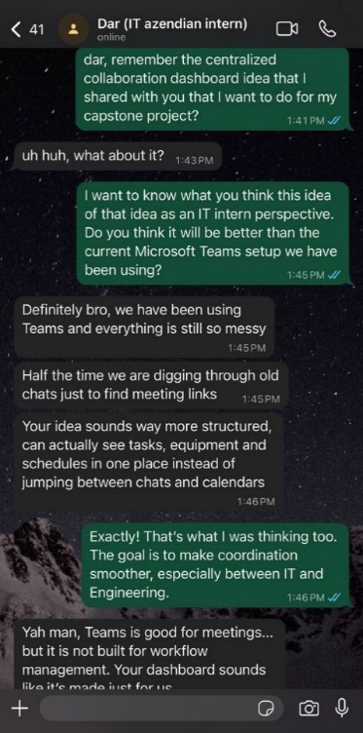

**Supervisor Comments:**

**1. Do they recognise this issue, and how are they addressing it currently?**

Yes, we are aware of this issue. As a relatively small and growing company, our resources are stretched quite thin, most of us juggle multiple projects at once. Because of that, we have not been able to dedicate specific manpower to build new internal tools or streamline document workflows. For now, we have been managing things manually through shared folders and Teams, though we know it’s not the most efficient approach.

**2. Have they considered any other solutions before?**

We have discussed a few potential approaches before, like using existing project management platforms or automating part of the workflow with scripts. But due to manpower constraints and the fact that many of us are still new to the system architecture and data pipelines, these ideas never got implemented fully. The focus has mainly been on delivering client projects first.

**3. How do they feel about your proposed solution; do they foresee any challenges?**

We think your proposed centralized dashboard solution is a good direction; it addresses a real pain point we have been facing for a while. The main challenge will be balancing this initiative with our ongoing deliverables, since it requires both IT and engineering inputs and most of the team is still getting used to the workflow. But overall, it is something we did like to see developed further once time and resources allow.



**Guidance Notes**

**Project Themes**

The proposed project should include an implementation and delivery of an engineering solution in the following focused areas:

|  |
| --- |
| SIE (Building Services) |
| 1. System performance, intelligence and sustainability in buildings 2. BIM and simulation technology 3. Health and wellbeing 4. Design and Practice 5. Workflow Process Optimisation via advanced tools (e.g. AI, ML, etc.) 6. Others (to be specified) |

**Project Real-Life Relevance**

* It is expected that the problem addressed by the student in this project will mirror the real-life issues experienced or observed by the student during his/her IWSP work placement.
* The project proposed may be a progression from his/her IWSP work, or a separate but relevant problem that arose from discussions with his/her work team during IWSP. Thus, students are encouraged to engage their current IWSP work team or supervisor for their inputs when proposing their project.
* The solution presented at the conclusion of this project is expected to have a relevant application in at least one of the five focused areas listed above and will be presented to project stakeholders (IWSP work reporting officer and SIT supervisory team) for comments and validation.

**Expected Scope of Work**

* Projects are to be conducted by the student individually but cross-referencing with another project with similar scope is acceptable. Project deliverables will be assessed individually.
* Students are to apply a design process involving design steps from problem definition, reviewing the conceptual system design, breaking down the system design into component design, prototyping at various stages of design, fabrication, and validating the design against the original intended application.
* The Student will need to take ownership of the project and maintain regular contact with project stakeholders for updating of progress and soliciting of feedback.

# Learning Outcomes

* Upon successful completion of the project, students will be able to:

1. Recall and apply an engineering design process
2. Employ fundamental engineering principles in determining design parameters
3. Design and develop an engineering solution to a real-life problem
4. Scrutinize and validate proposed engineering solution
5. Summarize and report the engineering solution and its design process